Windows Server 2019 installed with IP address highlighted from the firewall.

DNS active.

Windows Server 2019 with a static IP address of 192.168.1.10 and DNS server IP address of 192.168.1.1 which is also the default gateway from the pfSense firewall.

Windows 10 installed with its IP address highlighted from the firewall.

Static IP address for Windows 10 VM highlighted.

Windows 10 with the confirmation of DHCP settings working from the domain name (RTX.com) and IP address within the DHCP range.

Ubuntu VM installed.

The Ubuntu VM IP address as assigned by the firewall.

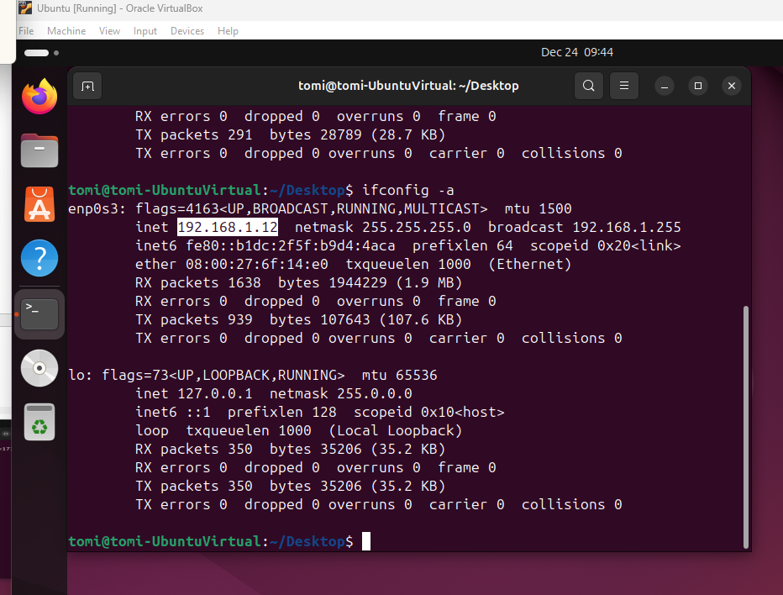

Static IP address for Ubuntu VM highlighted.

Windows Server 2019 configured with Active Directory, DNS and DHCP server. The server has now been promoted to a domain controller.

Created DHCP settings on Windows Server 2019.

The IP address range for the DHCP.

The address range on the Windows server.

Organizational units created in the domain name RTX.com.

Users created.

The Windows 10 VM and Ubuntu VM were created on the domain controller.

Group Policy Management indicating the forest and the domain on the domain controller.

The lease duration was set to one day.

Joining Windows 10 to the DHCP server.

Windows 10 domain joined with the DHCP server

Domain joined with DHCP server.

Ubuntu VM discovered domain name RTX.com. Joined with the DHCP server computers are the Windows 10 VM and Ubuntu VM.

User, jtalabi from the DHCP server is authenticated from the Ubuntu VM.

Logon failed from a user.

Logon activities from four different users.

Logoff activities from three different users.

The role of AD in accessing information.

* From a centralized location, AD can allow administrators to manage user accounts and permissions to network resources.
* AD provides directory services, storing information about a network and its users, devices and services.
* AD allows flexible and secure communication between domains and allows for scalability.
* AD allows for group policy management to enforce security settings and configurations across all devices within the network.

Review of security logs in a Security Operations Center.

- Security logs provide detailed records of network activity, thereby the easy detection of unusual behavior or activity is possible.

- Logs can serve as a source of evidence in investigations of activities or security breaches.

- Logs help in incident response because the source of an attack can be seen which can help in understanding the attack’s impact and guidance to the appropriate response.

- Logs monitor the performance of a network which helps in revealing any issues within the network.